EDF 3430: Measurement and Evaluation
Mark Quintana
Miteria Smith
October 9, 2019

- Unit: Geometry
- Grade Level: Four
- Subject: Mathematics
- Florida Standards: MAFS.4.MD.3.5
- Accommodations:
ESOL
a. C13- Visual representations

Objectives (6-8): At the end of this unit, student will be able to…
- Define angles
- Distinguish different angles by their characteristics
- Identify the measurements of angles
- Sketch angles of specified measurements
- Measure angles using protractor in whole-number degrees
- Bisect angles of specified angles
- Solve problems through addition and subtraction to find the value of the unknown value of an angle in a diagram
- Use an equation to find the value of unknown angles in a diagram.

Table of Specifications
Content Outline |  | Knowledge |  | Comprehension |  | Application |  | Analysis |  | Synthesis |  | Evaluation
Angles  Multiple choice |  |  |  |  |  |  |  |  |  | Multiple choice |  | Multiple choice
12 | 25% |  |  |  |  |  |  |  |  | 10% | 5 | 15% | 7
Explanation  True or false |  |  |  | Meaning of angles and give examples (true or false)
9 | 15% |  |  | 15% | 9
Solve  Calculations |  |  |  |  |  | Solve by addition, subtraction and use of equations
8 | 20% |  |  |  |  | 20% | 8
Characteristics of angles  Short answers |  |  |  |  |  |  |  | Distinguish different angle by highlighting characteristics(short answers)
6 | 20% |  |  |  |  |  |  | 20% | 6
Construction  Measurement and construction |  | Measurement and construction
5 | 20%
Totals |  | 20% | 5 | 15% | 9 | 20% | 8 | 20% | 6 | 10% | 5 | 15% | 7

Mathematics
Geometry

Grade: 4th Name:_________________
Subject: Social Studies Date:___________________

Multiple choices

- A prism has
- Only triangular faces.
- No point.
- Curved faces.
- Parallelogram sides.

- All of the sides of this triangle are equal. What kind of a triangle is this?
- scalene
- isosceles
- equilateral
- right triangle

- A scalene triangle has
- Three equal sides.
- Three uneven sides.
- Two equal sides.
- Two square corners.

- John's teacher asked him to draw a quadrilateral with all congruent sides. What could he draw?
- a rectangle or a rhombus
- a rectangle or a square
- a square or a rhombus
- a trapezoid or a kit

- Which of the following could be the side lengths of a right triangle?
- 3, 13, and 14
- 4, 5, and 6
- 4, 9, and 10
- 5, 10, and 15
- 5, 12, and 13

- Which one is NOT a name for this figure?
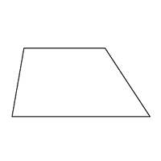
- polygon
- quadrilateral
- parallelogram
- triangle

- Which statement about quadrilaterals is true?

- All rectangles are always squares.
- All squares are always rhombuses.
- All trapezoids are always parallelograms.
- All rectangles are always parallelograms

- How many faces does a cube have?
- 4
- 6
- 8
- 10

- How many millimeters are in a meter?
- 1
- 10
- 100
- 1000

- An acute triangle is a triangle with acute angles.
- one
- two
- three
- four

- A parallelogram is a square.
- never
- sometimes
- always

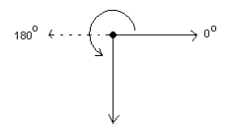
What is the measure of the solid line angle depicted by the following figure?

- 90 degrees
- 180 degrees
- 225 degrees
- 270 degrees
- 0 degrees

True of false
- Angles are measure in degrees
- True
- False

- The sum of angles at a point add up to 270 degrees
- True
- False

- Corresponding terms for Pattern A and Pattern B are shown.
Pattern A: 8, 12, 16, 20
Pattern B: 24, 36, 48, 60
each term in Pattern A is 3 times the corresponding term in Pattern B.
- True
- False

- All angle in a cyclic triangle do not add up to 360 degrees
- True
- False

- An isosceles triangle has three congruent sides.
- True
- False

- Some quadrilaterals are parallelograms.
- True
- False

- A triangular pyramid is a 3 dimensional shape with five vertices
- True
- False

- This quadrilateral is a parallelogram.
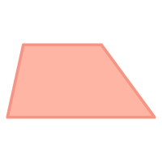
- True
- False

- The sum of the measures of the interior angles of a hexagon is 720°
- True
- False

Short answer
- Lucy says the shape shown is not a parallelogram because all four sides are not the same length. Is Lucy's reasoning correct and why?
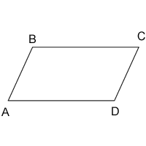

- This triangle has no congruent sides. State the qualities of the triangles and name the triangle
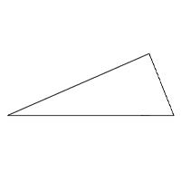

- The table shows the side lengths of quadrilateral ABCD.
Quadrilateral ABCD
Side | Length
AB | 4
BC | 8
CD | 6
DA | 6
Is quadrilateral ABCD a parallelogram?

- Which of the following are parallelograms? Give a reason
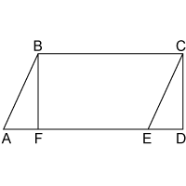.

- State the key feature of right-angled triangle

- Why the shape shown is not a parallelogram?

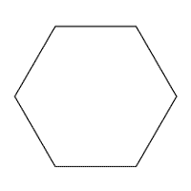
Calculations
- Side AC of the triangle measures 4 units and side BC measures 3 units.
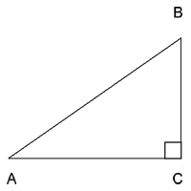
If you plot the triangle on a coordinate plane with point A at the origin (0, 0) and point C at (4, 0), what are the coordinates of point B?

- Find the measure of the missing angle in the triangle below.
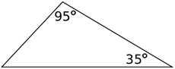

- The figure below is a parallelogram with two angles given in terms of x. Determine the value of x.
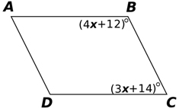

- The figure below is an equilateral triangle with sides of length 6. What is the area of the triangle?
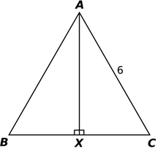

- Each cube measures 1 cubic unit in volume. What is the total volume of all the cubes combined?

- In this right rectangular prism, each small cube measures 1 centimeter on each side.
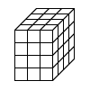
How many cubes make the prism?

- Calculate the values of angles at a point in the figure below

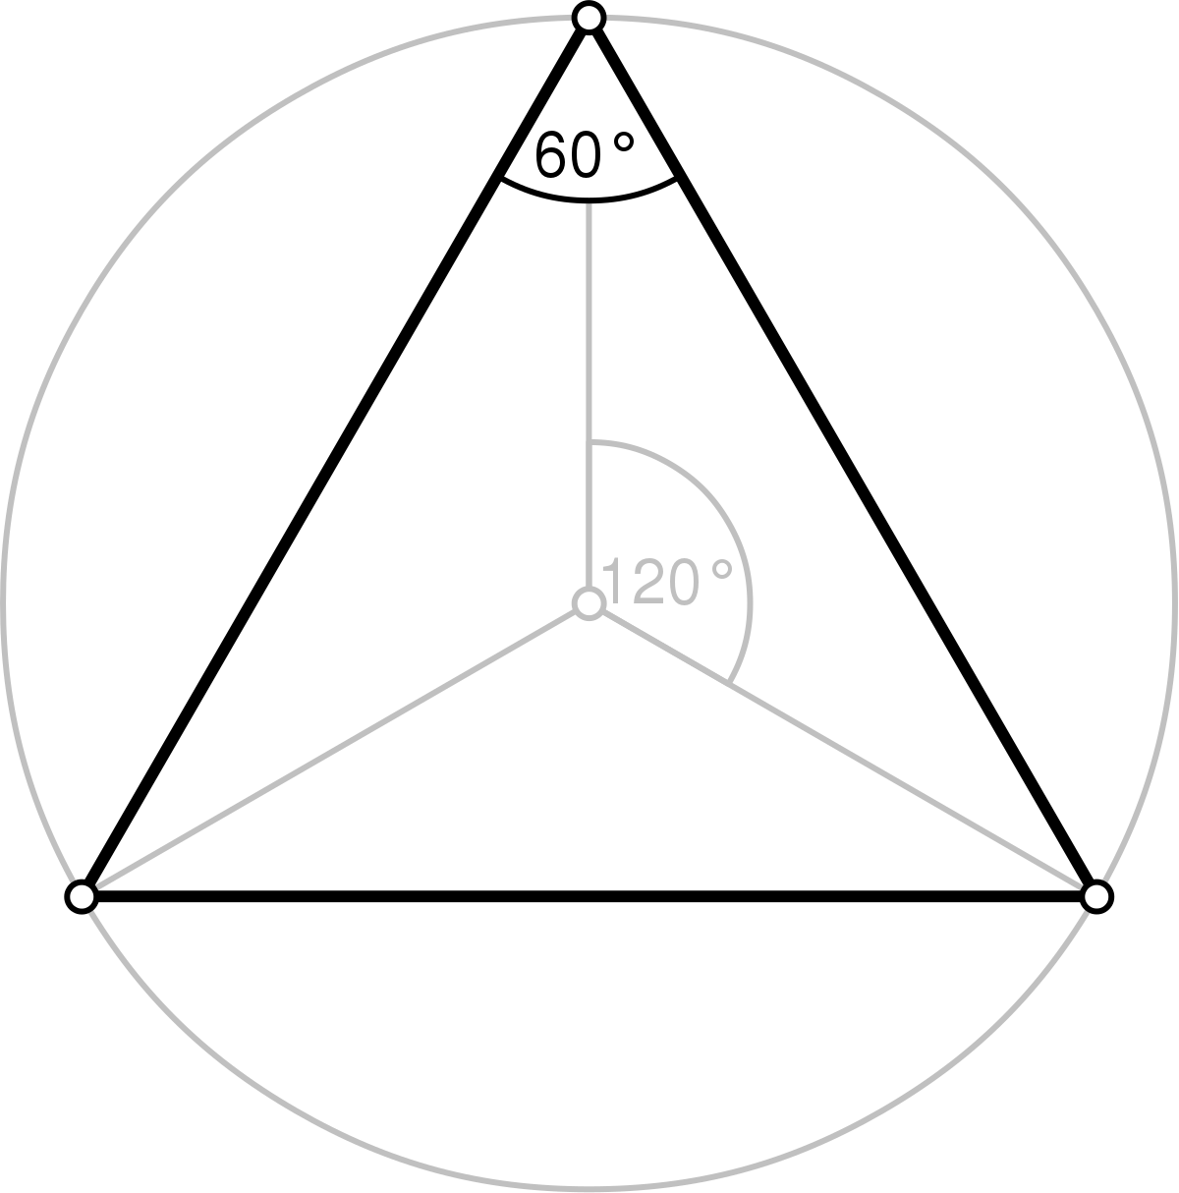

- Tom made a figure that was 4 cubes long, 3 cubes wide and 1 cube high. How many cubes did he use?

Measurement and construction
- Using a protractor measure the angles in the figure below.

- Using a compass and a ruler, construct a triangle measuring 3cm by 5cm by 4cm. state the type of triangle.

- Using the triangle drawn above calculate the value of angle in the diagram. Calculate the area of the triangle.

- Represent the following coordinates of triangle and state the type of triangle (7,0), (3,7), (0,5)

- According to angle measure, what kind of triangle is this? Measure all side using a rule
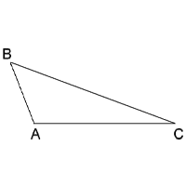

Answer key
- A (Evaluation)

- C (Evaluation)

- B (Evaluation)

- D (Evaluation)

- E (Evaluation)

- D (Evaluation)

- D (Evaluation)

- B (Synthesis)

- D (Synthesis)

- C (Synthesis)

- A (Synthesis)

- D (Synthesis)

True or false
True False
- A (Comprehension) 2. B (Comprehension)
3. A (Comprehension) 4. B (Comprehension)
5. A (Comprehension) 6.B (Comprehension)
7. A (Comprehension)
8. A (Comprehension)
9. A (Comprehension)

Short answer
- No, Lucy is incorrect. The shape is a parallelogram because it has four sides and the opposite sides are parallel. (Analysis)

- This is a scalene triangle. It qualities are; unequal side or angles, the angle of the triangle can be acute angles, obtuse angle or right angle. The triangle has no line of symmetry. (Analysis)

- Maybe. It could be a parallelogram, but the table needs to include angle measures in order to determine. (Analysis)

- ABCE, line AE is parallel to line BC (only one answer is required). (Analysis)

- All right triangles have 90-degree, or right angles. (Analysis)

- It has more than four sides. (Analysis)

Calculations
- (3,4) (Application)

- 50 (Application)

- X=22 (Application)

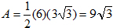

- 15 cubic units (Application)

- 48 cubes (learners should demonstrate multiplication method). (Application)

- All angles are 120 degrees (Application)

- 12 (Application)

Measurements and construction
- Angle 60, 30 (Knowledge)

- Right angled triangle (Knowledge)

- Area = 6 square cm. (Knowledge)

- Right angle triangle (Knowledge)

- acute triangle AB= 1.5cm, AC= 3.1, BC=3.7 (accept +_ 1) (Knowledge)

EDF 3430 Project 1: Instructional Objectives and Test Construction Rubric
EDF 3430 Project 1: Instructional Objectives and Test Construction Rubric
 | Exceeds Expectations (10-8pts) | Meets Expectations (7-5 pts) | Does Not Meet Expectations (4-1 pt) | No Attempt (0 pt) | Points
Title | Full description of subject area, grade level, unit covered, standards and list of accommodations. | The description is missing one piece of information such as the subject area OR grade level. | The description is missing two or more pieces of information. | Failed to submit, or failed to submit on time
List of Objectives Instructional Design & Lesson Planning FL-FAU-FEAP-2013.A.1.a | 6-8 objectives  All objectives, including action verbs, are clear, measurable and age/grade appropriate. No grammatical errors. | 6-8 objectives. Some objectives are unclear  1-2 objectives are not measurable or appropriate. One or two grammatical errors. | Less than 6 objectives  Unclear objectives  Most objectives are not measurable and appropriate. | Failed to submit, or failed to submit on time
Table of Specifications (Elements: Content Domains, Bloom’s Taxonomy, Classification of Objectives, and item numbers and percentages) | The table contains ALL elements. All objectives are classified correctly.  Correct distributions of items according to the importance of each objective. No errors in computing the percentages. | The table is missing 1 or 2 important elements.  Less than 3 misclassifications of objectives. Less than 5 errors in distributing the items and percentages | The table is not structure correctly with all necessary elements  More than 3 misclassifications of objectives. More than 4 errors in distributing the items or computing the percentages | Failed to submit, or failed to submit on time
Assessment Matches Plan Assessment FL-FAU-FEAP-2013.A.4.b | All 20 questions (minimum) included in test. Questions are classified according to the table of specifications.  Directions are provided in detail for students using proper format  Answer key is provided; all items are free of technical errors and matches the questions. | At least 15 questions out of 20 match with the objectives outlined in the table of specification.  Directions are general using proper format.  Answer key is provided, fewer than 5 errors in the writing of items and all items are clear, slight arrangement errors in questions. | Fewer than 20 questions. Questions do not match with all objectives in table of specification. Directions are ambiguous or missing.  No answer key provided and /or more than 5 technical errors in item writing resulting in unclear questions. | Failed to submit, or failed to submit on time
Item Format and technical aspects | Use more than four question formats in the assessment in a correct order and without error. No grammatical errors | Use four different question formats in the assessment in correct/incorrect order. Less than 3 grammatical errors | Used less than four question formats in the assessment. Four or more grammatical errors. | Failed to submit, or failed to submit on time

Standards
FL-FAU-FEAP-2013.A.1.a
Aligns instruction with state-adopted standards at the appropriate level of rigor;
FL-FAU-FEAP-2013.A.4.b
Designs and aligns formative and summative assessments that match learning objectives and lead to mastery;

: ____________/ 50 Points Possible

